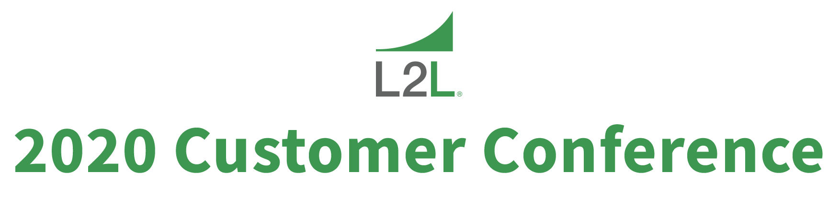

Justification of Attendance Letter

I’m writing to request approval to attend the Leading2Lean 2020 Customer Conference – Capture, Analyze, Improve, to be held May 12-13, 2020 in Salt Lake City, UT. This event offers the most concentrated opportunity of the year to:
- Learn about proven strategies for capturing and analyzing data to drive improvement
- Learn from my peers and Leading2Lean about customer successes and lessons learned
- Learn best practices in using CloudDISPATCH™ to improve operations
- Learn about new Lean Tools and Mfg 4.0 features to help us succeed in 2020
- Explore integration capabilities and helpful examples

I believe attending this event will give us tools and practical knowledge that will help to accelerate our progress and increase our competitiveness in our industry. In particular, I’d like to focus on finding solutions that could help us address the following issues, or benefit these projects:

- _____________________________________________________________________________
- _____________________________________________________________________________
- _____________________________________________________________________________

Here is a breakdown of the conference costs:
Airfare to Salt Lake City, UT $_______
Hotel (2 nights at Hilton Salt Lake City Center @ $179 + tax) $358 + tax
Registration fee (early bird of $1,000 for individual, or $800 for 3+ people) $_______

If I register before March 15, 2020, I will save $200 on the full conference registration. I’m confident this event will deliver big returns for us. In fact, I can submit a post-conference report that will include a summary of lessons learned, key take-aways to help us improve, and recommendations to maximize the benefits of CloudDISPATCH™.

